**AULIA ALFINA RAHMADANTI**

**20180801369**

**TEKNIK INFORMATIKA**

**Basis data**

**1.** **DESC PRODUCT_NOV**

**INSERT INTO PRODUCT_NOV**

**VALUES('001','BAJU ANAK','PRIA','40000','20000','-','-')**

**SELECT * FROM PRODUCT_NOV**

**INSERT INTO PRODUCT_NOV**

**VALUES('002','BAJU DEWASA','WANITA','150000','50000','-','-')**

**SELECT * FROM PRODUCT_NOV**

**INSERT INTO PRODUCT_NOV**

**VALUES('003','BAJU BAYI','PRIA&WANITA','90000','50000','-','-')**

**SELECT * FROM PRODUCT_NOV**

**Hasil RUN.**

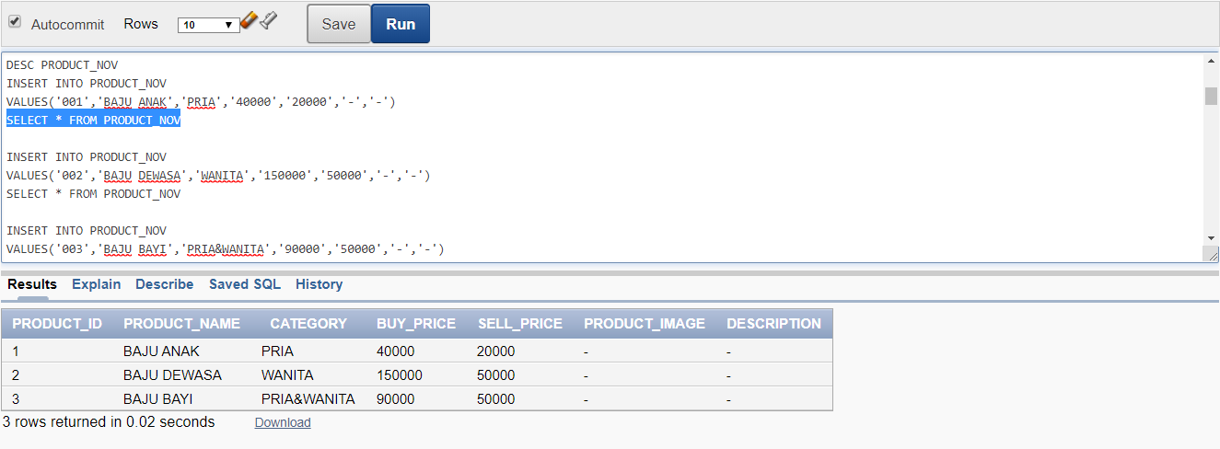

**2.** **DESC CUSTOMER_NOV**

**INSERT INTO CUSTOMER_NOV**

**VALUES(001,'FARO','SETYA','NINGSIH','PARUNG PANJANG','a@gmail.com','08123456')**

**SELECT * FROM CUSTOMER_NOV**

**INSERT INTO CUSTOMER_NOV**

**VALUES(002,'PUTRA','RAHMA','YANTO','BITUNG','b@gmail.com','08123457')**

**SELECT * FROM CUSTOMER_NOV**

**INSERT INTO CUSTOMER_NOV**

**VALUES(003,'AURA','KASIH','DAMAYANTI','CIMONE','c@gmail.com','08123458')**

**SELECT * FROM CUSTOMER_NOV**

**HASIL RUN**

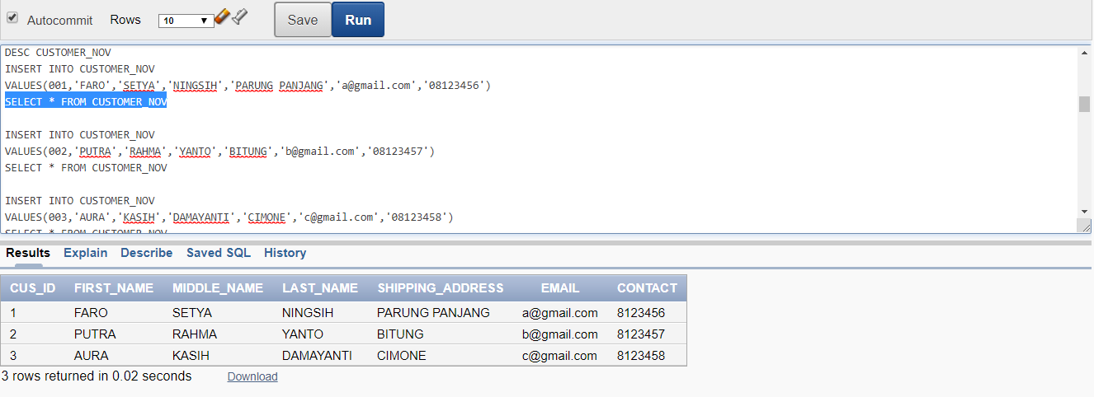

**3. DESC ORDER_NOV**

**INSERT INTO ORDER_NOV**

**VALUES(001,'2','07/01/19','DELIVER')**

**SELECT * FROM ORDER_NOV**

**INSERT INTO ORDER_NOV**

**VALUES(002,'1','10/03/19','DELIVER')**

**SELECT * FROM ORDER_NOV**

**INSERT INTO ORDER_NOV**

**VALUES(003,'2','11/03/18','DELIVER')**

**SELECT * FROM ORDER_NOV**

**HASIL RUN**

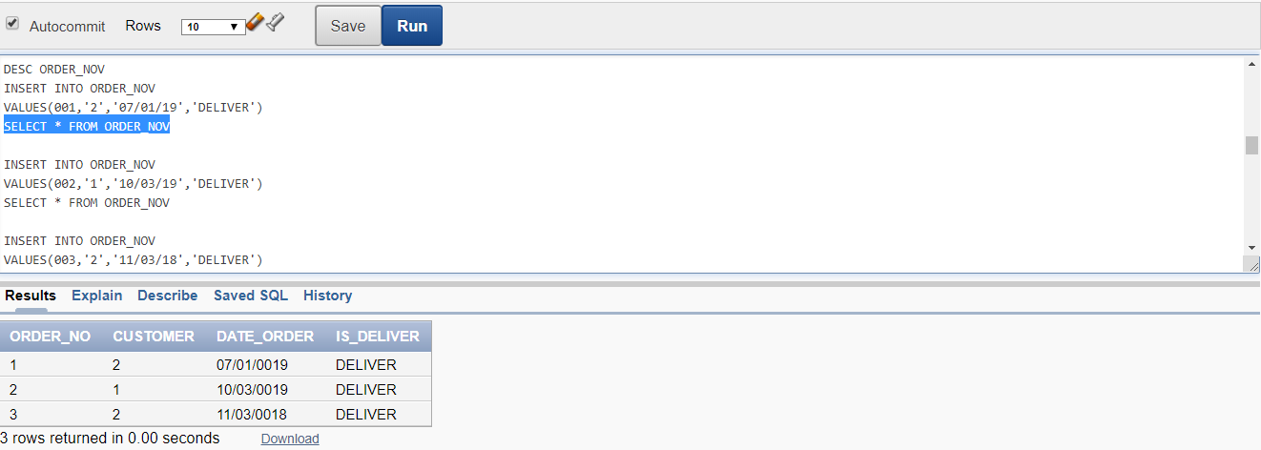

**4. DESC STOCK_NOV**

**INSERT INTO STOCK_NOV**

**VALUES('001','5','05/10/18','001')**

**SELECT * FROM STOCK_NOV**

**INSERT INTO STOCK_NOV**

**VALUES('002','8','09/10/17','002')**

**SELECT * FROM STOCK_NOV**

**INSERT INTO STOCK_NOV**

**VALUES('003','4','03/11/19','003')**

**SELECT * FROM STOCK_NOV**

**HASIL RUN**

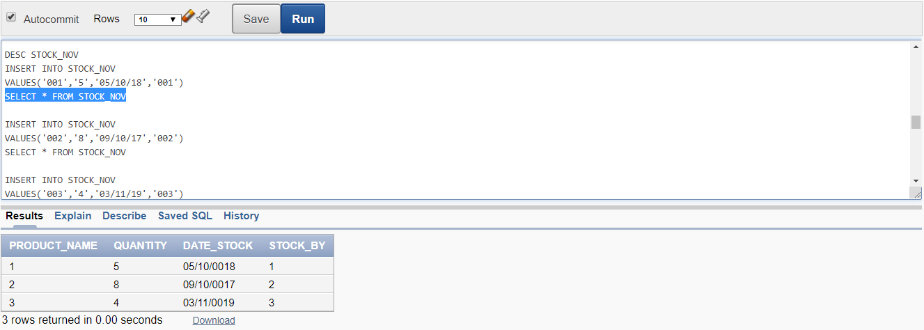

**5. DESC ORDERDETAILS_NOV**

**INSERT INTO ORDERDETAILS_NOV**

**VALUES('001','001','5')**

**SELECT * FROM ORDERDETAILS_NOV**

**INSERT INTO ORDERDETAILS_NOV**

**VALUES('002','002','10')**

**SELECT * FROM ORDERDETAILS_NOV**

**INSERT INTO ORDERDETAILS_NOV**

**VALUES('003','003','4')**

**SELECT * FROM ORDERDETAILS_NOV**

**HASIL RUN**

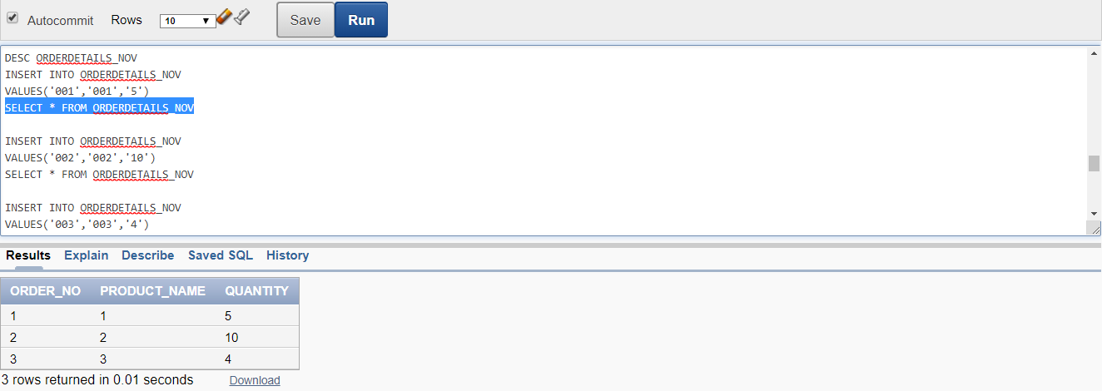

**6. SELECT a.ORDER_NO, a.DATE_ORDER, c.FIRST_NAME, b.PRODUCT_NAME, b.QUANTITY, d.SELL_PRICE,**

**b.QUANTITY*d.SELL_PRICE as total**

**FROM ORDER_NOV a, ORDERDETAILS_NOV b, CUSTOMER c, PRODUCT d**

**WHERE b.ORDER_NO = a.ORDER_NO and c.CUS_ID = a.CUSTOMER and b.PRODUCT_NAME = d.PRODUCT_ID**

**HASIL RUN**

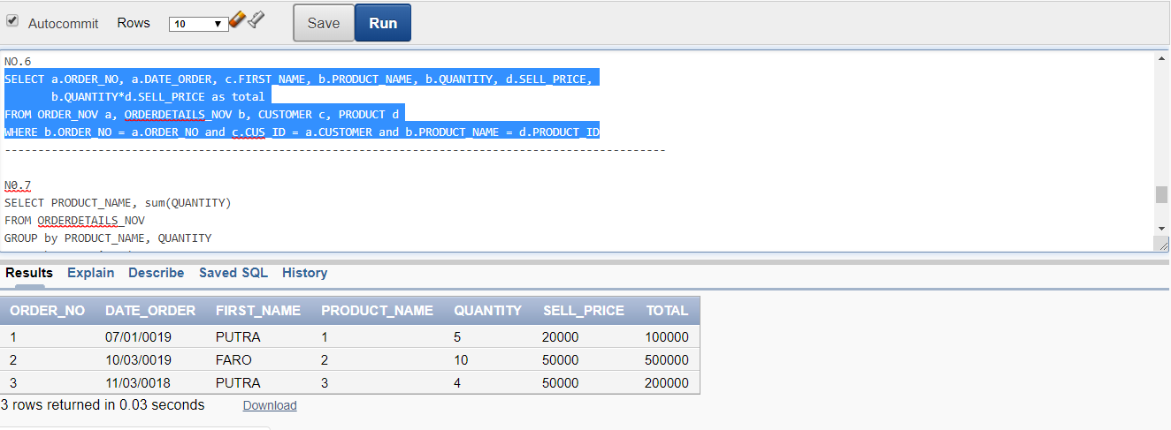

**7. SELECT PRODUCT_NAME, sum(QUANTITY)**

**FROM ORDERDETAILS_NOV**

**GROUP by PRODUCT_NAME, QUANTITY**

**ORDER by quantity desc**

**HASIL RUN**

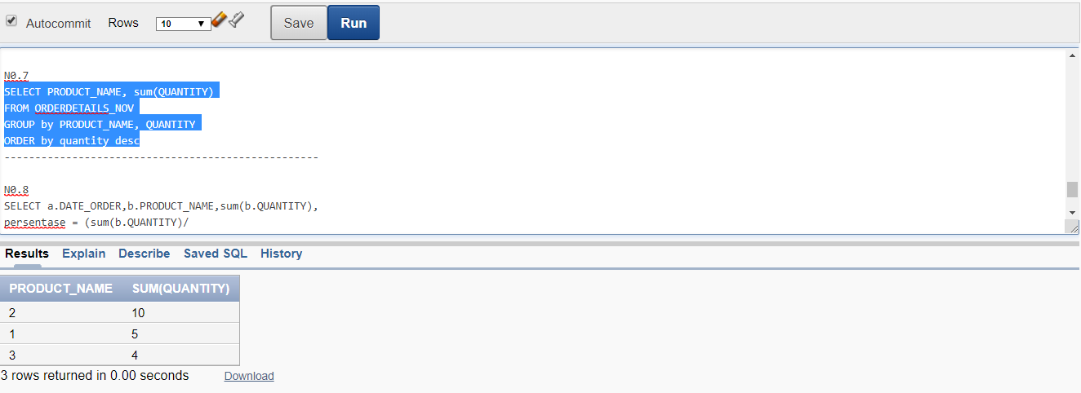

**8. SELECT a.DATE_ORDER,b.PRODUCT_NAME,sum(b.QUANTITY),**

**persentase = (sum(b.QUANTITY)/**

**SELECT sum(d.QUANTITY)**

**FROM ORDER_NOV c.ORDER_NO and c.ORDERDETAILS_NOV d**

**WHERE d.ORDER_NO = c.ORDER_NO and c.DATE = '2019-11-16)*100**

**FROM ORDER_NOV a, ORDERDETAILS_NOV b**

**WHERE b.ORDER_NO = a.ORDER_NO and a.DATE = '2019-11-16'**

**GROUP BY a.DATE_ORDER,b.PRODUCT_NAME,b.QUANTITY**